

B.TECH COMPUTER SCIENCE AND ENGINEERING

CSE 326

**PROJECT TITLE**

INSURANCE MANAGEMENT

NAME: SAMSON KWAKU NKRUMAH

REG NO.: 11919729

ROLL NO.: 70

SECTION: K19JP

NAME: YOGENDRA KATARA

REG NO.: 11905058

ROLL NO.: 09

SECTION: K19JP

NAME: SUARABH RAI

REG NO.: 11905175

ROLL NO: 62

SECTTION: K19JP

NAME: ARIJEET MANDAL

REG NO.: 119I4157

ROLL NO: 60

SECTTION: K19JP

**DECLARATION**

I hereby declare that the project entitled, “Insurance Management” for the course CSE326 is submitted by me (Samson Kwaku Nkrumah, Yogendra Katara and Suarabh Rai) to Dr. Dhanpratap Singh of Lovely Professional University Department of Computer Science and Engineering, lecturer of the course CSE326. Is an authentic project solely carried out by us to fulfilling the course requirement. Every single detail in this project is based on our own way of implementing the problem

Samson Kwaku Nkrumah(11919729)

Yogendra Katara(11905058)

Suarabh Rai(11905175)

**CONTENTS**

1. **DECLARATION…………………………………………..3**
2. **CONTENT…………………………………………………4**
3. **INTRODUCTION…………………………………………5**
4. **USER INTERFACE………………………………………6**
5. HomePage……………………………………………6
6. Insurance Plans Page…………………………………7
7. Login page……………………………………….......8
8. Sign up page…………………………………………8
9. Insurance Plan……………………………………….9
10. **DEDUCTIONS……………………………………………10**
11. **CONCLUSION……………………………………………10**

**INTRODUCTION**

**Insurance** is a means of protection from financial loss. It is a form of risk management, primarily used to hedge against the risk of a contingent or uncertain loss.

The purpose of this project is to build a software for handling the management digitally. This helps in many ways thereby bringing people all over on to a single platform and easily mange their insurance.

Insurance management is a non-technical term used to describe insurance brokers and providers and the insurance products they offer buyers. Insurance providers sell various insurance solutions to business and consumer buyers. There are many other insurance platforms but what makes ours outstanding is the insurance policies that we have. There are so many insurance policies in our app, that helps

We name our project as **Blim Insurance.** Is just a unique name we have taken. Our pages are responsive and fits well in mobile devices as well. We used popular frameworks and libraries such as bootstrap, jquery, fontawesome, vendor, etc. Most styles were done by different group members thereby providing more stylesheet(css files in the project).

**HOMEPAGE**

The homepage also known as the landing page, is the page that viewers first see when they visit the website. It was created by Samson Kwaku Nkrumah. It carries the navigation to contacts page, insurance plans page, login page, and sign up page.



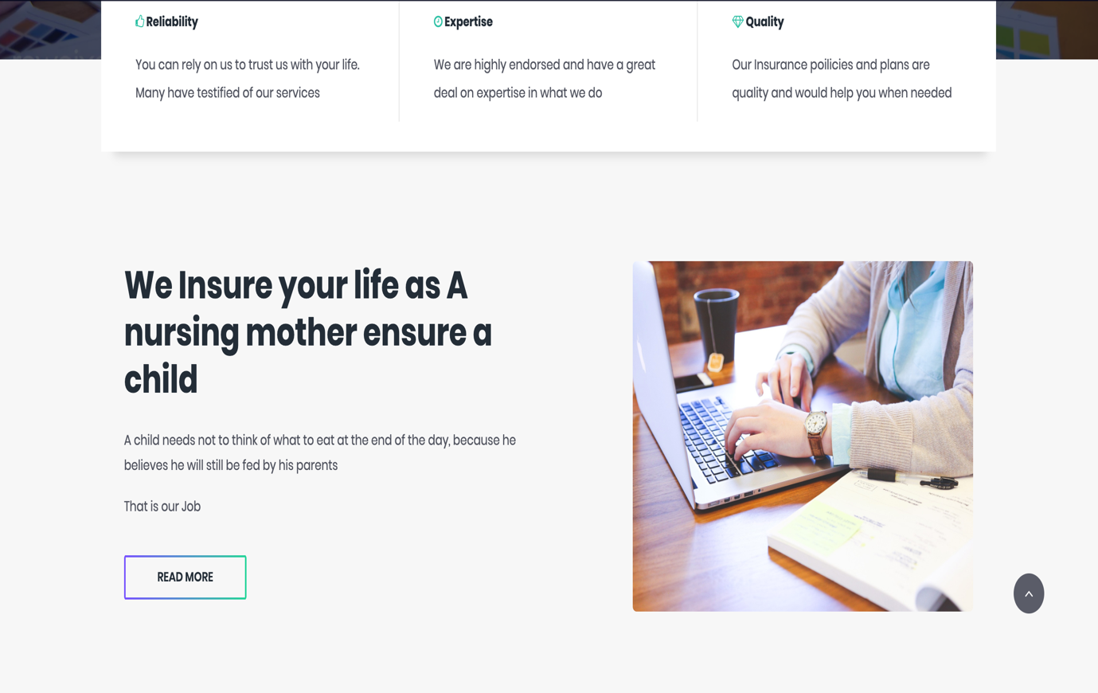

**INSURANCE PLANS PAGE**

The page consists of the insurance policy which we have in our webpage based on research and also the number of products we insure such as health, finances, business, etc. This page was also designed by Samson Kwaku Nkrumah

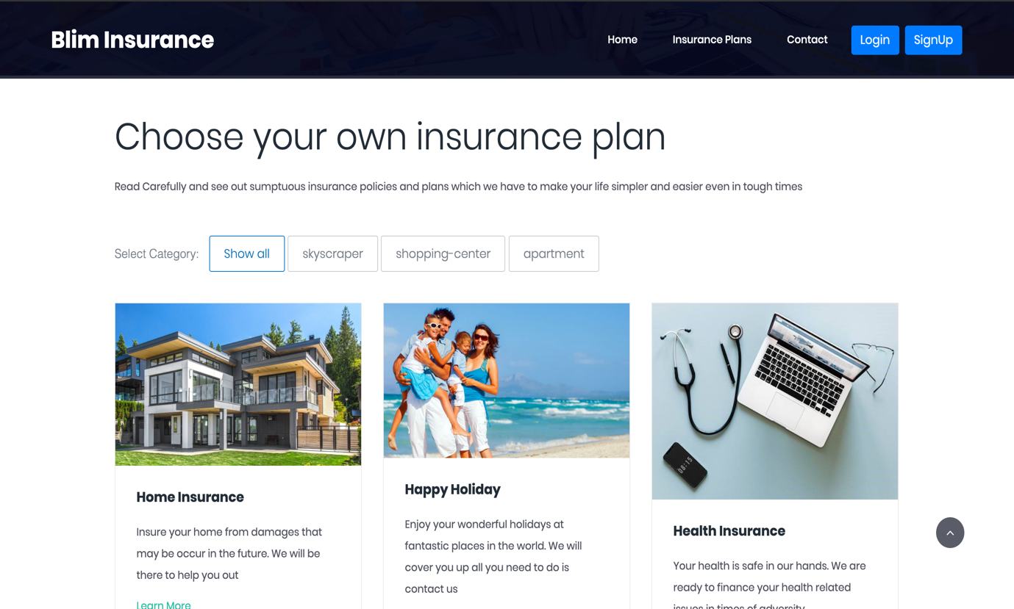

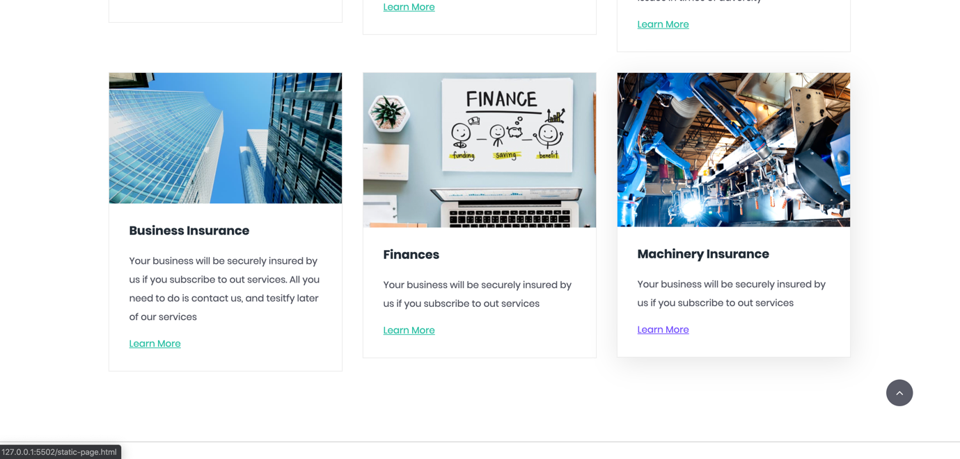



**LOGIN PAGE**

This is the page where the use is authenticated before moving on to the userpage. If invalid details are provided, the user won’t get to the login page. There is no backend to handle the authentication and verification. This page was created by Yogendra Karata.

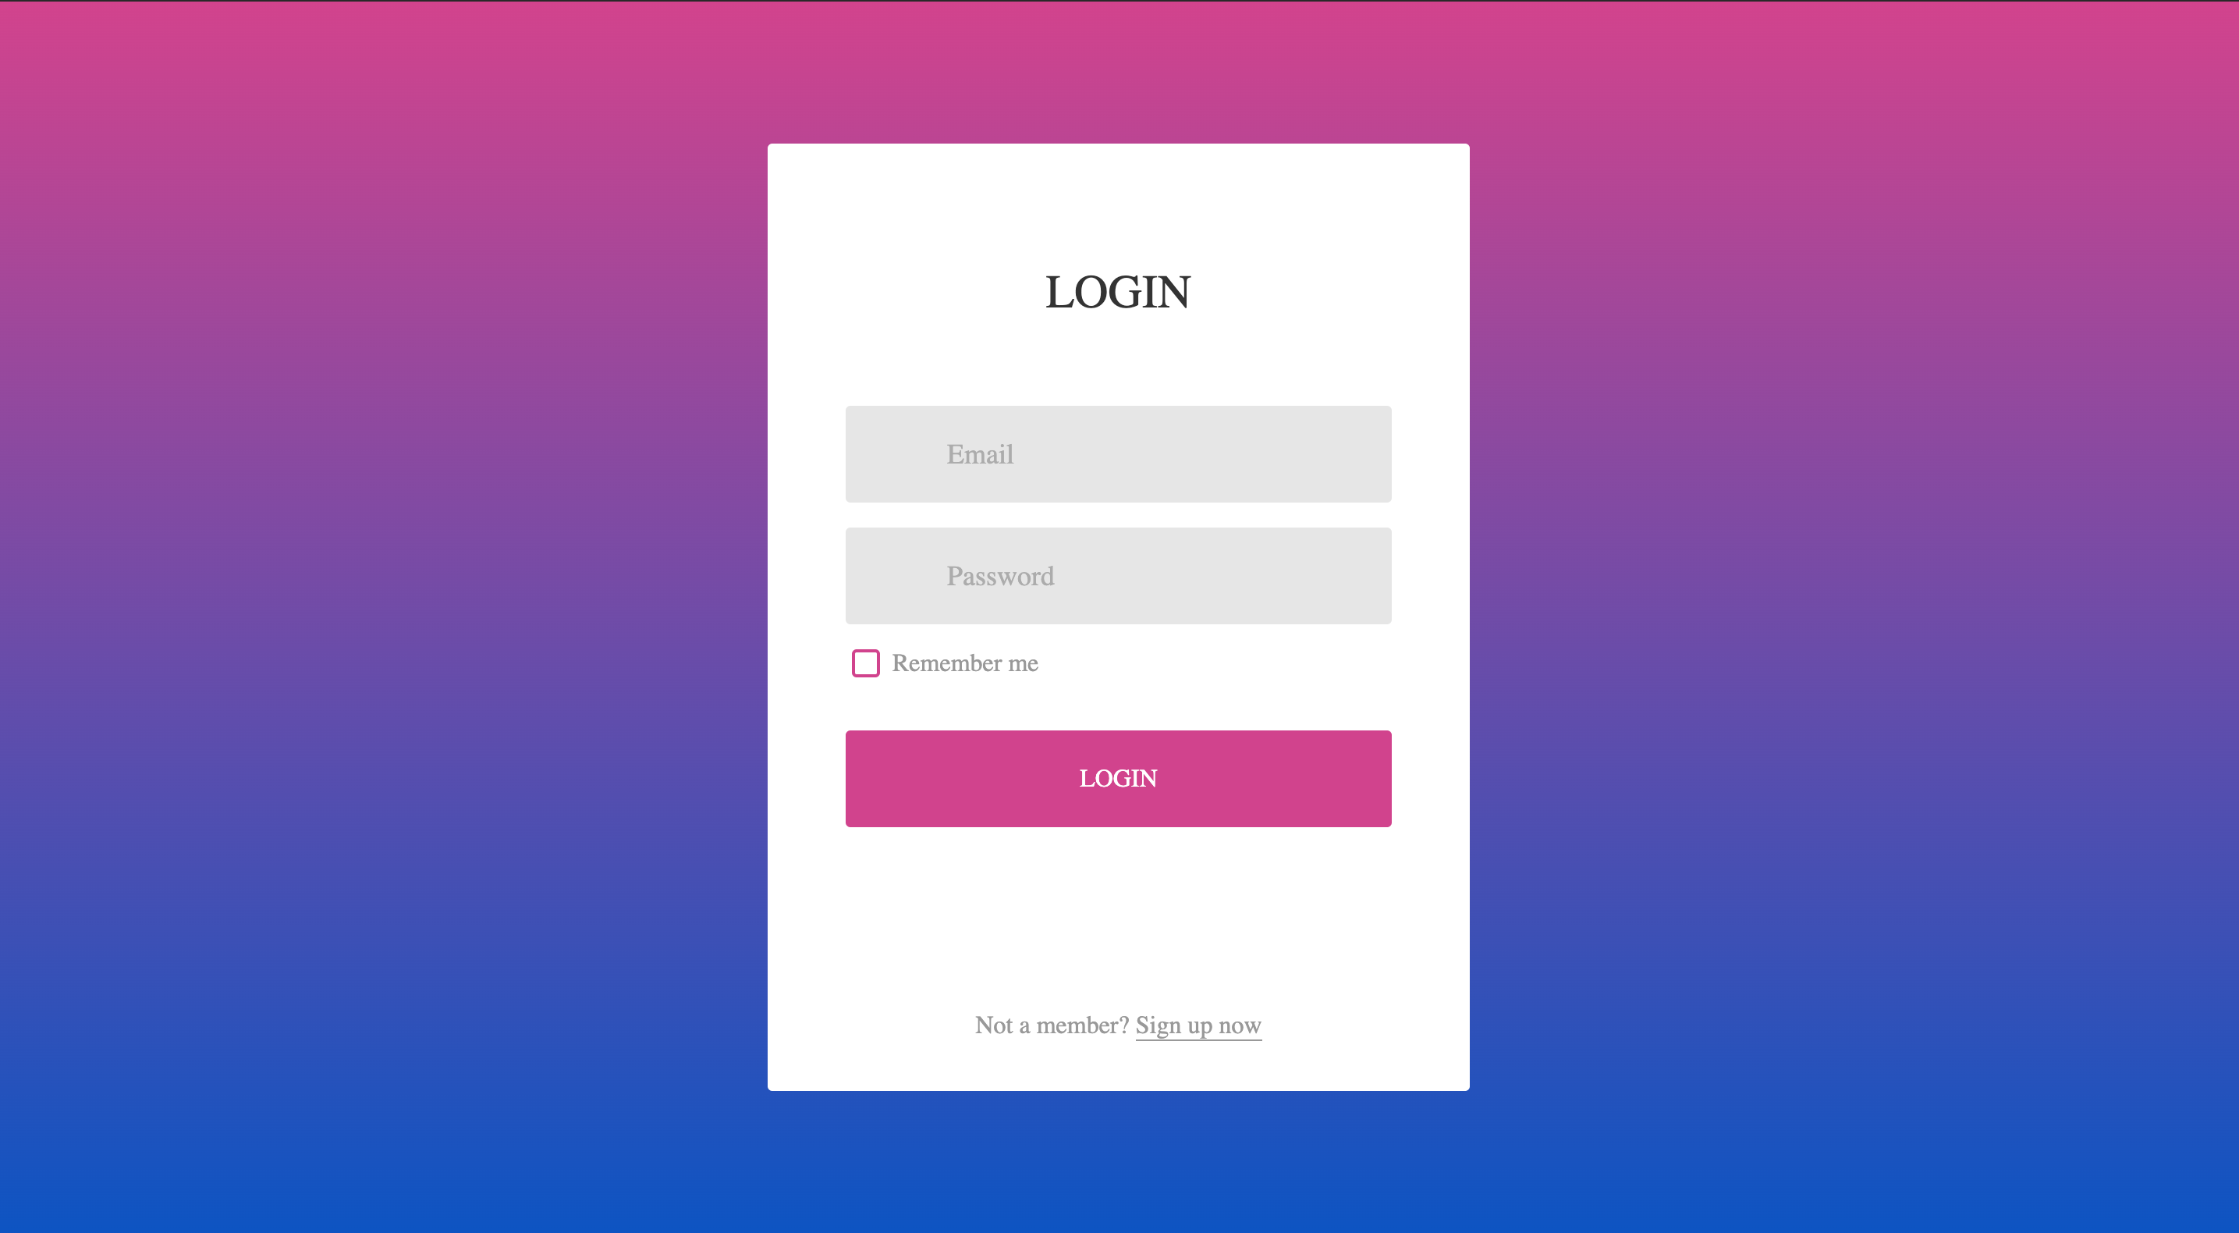

**SIGNUP PAGE**

This contains the page where the user is registered in the insurance database. Before he or she can have access to the userpage through the login. This page was designed by Suarabh Rai



**CONTACTS PAGE**

This consist of the page where visitors of the website or user of the site can contact the system administrator in case of any problem or issue or bug in the page. And also contact the Insurance agency for further questions on insurance plans and policies. This page was developed by Arijeet Mandal and Samson Kwaku Nkrumah



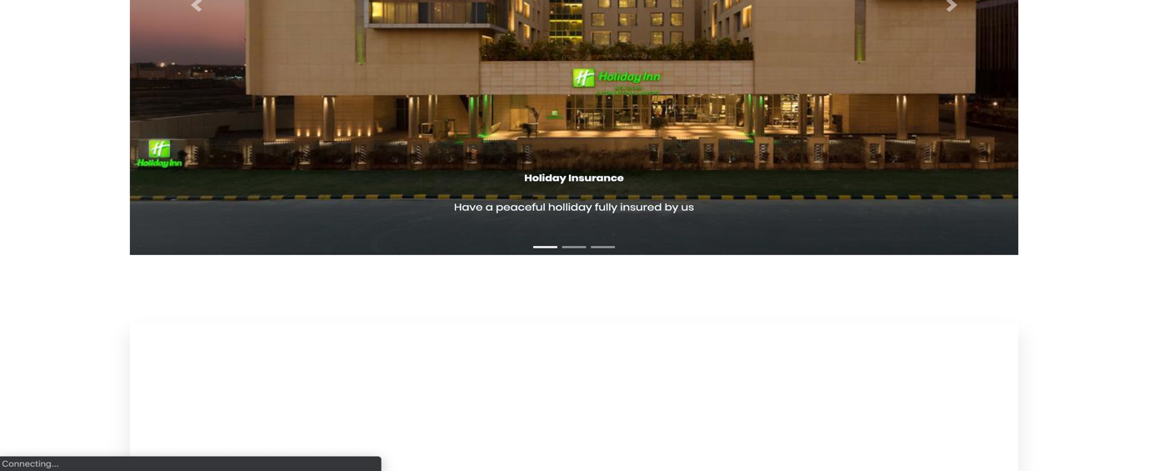

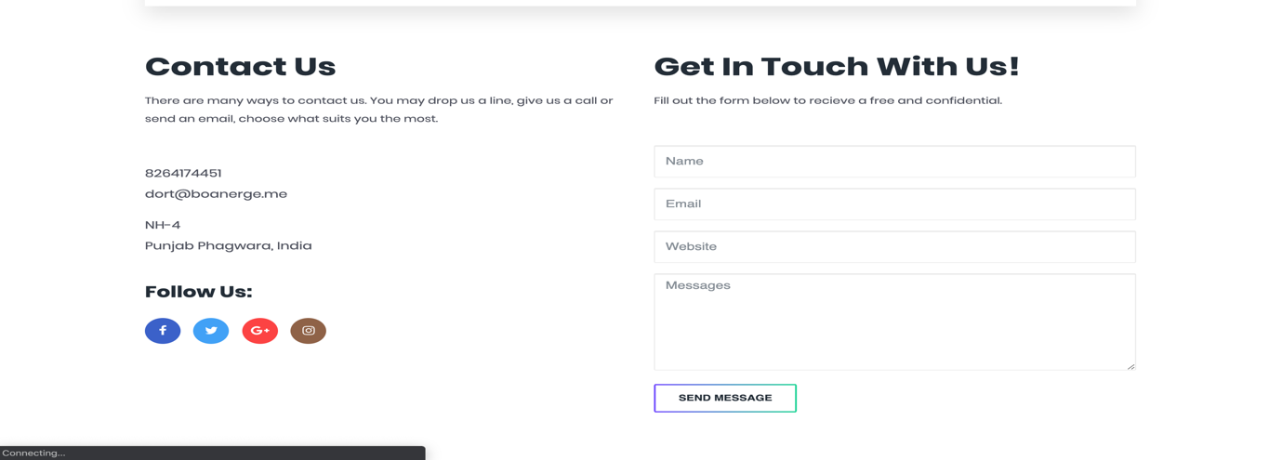

**DEDUCTIONS**

The pages were created with the help of some popular frameworks and libraries such as bootstrap, vendor, fontawesome,jquery. All though some of the pages have been created, not all were created because that would be much more pages, such as;

1. Userpage
2. User profile page
3. Settings page
4. Insurances page(Purchased insurances)
5. Insurance page(Form filling page)

And many other which we haven’t even considered. Which would involve much logic and validations done by the developers.

**CONCLUSION**

In conclusion this project was done to fulfilling the course requirement of CSE326. This project was solely done by the group members with intensive work and thinking. Our Stylings are also responsive and fit nicely in mobile and other devices as well. We are hereby taken charge of this project as our own work. If Any question is needed you can contact any of the group members and the problem will be resolved. Thank you.